Methodological recommendations
for Summative Assessment

English

Grade 2
Methodological recommendations for Summative Assessment are designed to assist teachers in planning, organizing and carrying out Summative Assessment in “English” for the Grade 2 learners. Methodological recommendations are aligned with the Subject Programme and Course plan. Summative Assessment in Grade 2 is conducted in Terms 1, 2, 3 and 4.
Summative Assessment Tasks for unit/cross curricular unit will allow teachers to determine the level of the learning objectives achievement planned for the term. Methodological recommendations comprise tasks, assessment criteria with descriptors and marks for conducting Summative Assessment across the unit/cross curricular unit. Also this document includes possible levels of the learners’ academic achievement (rubrics). Tasks with descriptors and marks can be considered as recommendations.
Summative Assessment Specification with mark scheme is suggested for conducting at the end of the term. It is standardized and is obligatory to adhere to for conducting Summative Assessment for the term.
Methodological recommendations are designed for primary school teachers, school administrations, educational departments’ seniors, regional and school coordinators in criteria-based assessment and others.

Free access to the Internet resources such as pictures, cartoons, photos, texts, video and audio materials, etc. have been used in designing these Methodological recommendations.

Contents
TERM 1 4
SUMMATIVE ASSESSMENT TASKS 4
Summative Assessment for the Cross curricular unit “All about me” 4
Summative Assessment for the Cross curricular unit “My family and friends” 7
Specification of Summative Assessment for term 1. 10
TERM 2. 15
SUMMATIVE ASSESSMENT TASKS 15
Summative Assessment for the Cross curricular unit “My school” 15
Summative Assessment for the Cross curricular unit “The world around us” 18
Specification of Summative Assessment for term 2. 21
TERM 3 26
SUMMATIVE ASSESSMENT TASKS 26
Summative Assessment for the Cross curricular unit “Health and body” 26
Summative Assessment for the Cross curricular unit “Traditions and customs” 29
Specification of Summative Assessment for Term 3. 32
TERM 4 38
SUMMATIVE ASSESSMENT TASKS 38
Summative Assessment for the Cross curricular unit “The natural environment” 38
Summative Assessment for the Cross curricular unit “Travel” 42
Specification of Summative Assessment for term 4. 45

TERM 1

SUMMATIVE ASSESSMENT TASKS

Summative Assessment for the Cross curricular unit “All about me”

Learning objectives | 2.L2 Recognize with considerable support an increasing range of common personal questions  2.S8 Give simple instructions for others to follow
Assessment criteria | - Identify personal questions with considerable support  - Give simple commands to follow
Level of thinking skills | Knowledge and comprehension  Application
Duration | 20 minutes
Listening

Task 1. Listen to the questions. Answer the questions.
What is your name?
How old are you?
What colour is your hair?
What colour are your eyes?
Where are you from?

Task 2. Look at the pictures. Listen to the questions twice. Circle Yes or No answers.
- Does he brush his teeth? Yes No
- Does she play tennis? Yes No
- Does he wash his face? Yes No
- Do they watch TV? Yes No
- Do they play football? Yes No

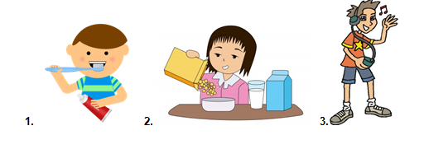
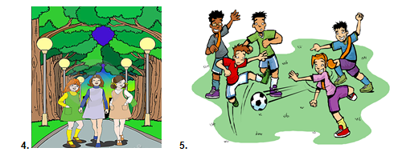

Speaking
Task 3. Look at the pictures. Give simple instructions to your classmate. The class follows them.
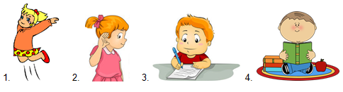

Assessment criteria | Task | Descriptor | Mark
 |  | A learner
Identify personal questions with considerable support. | 1 | says his/her name; | 1
 |  | says his/her age; | 1
 |  | says colour of his/her hair; | 1
 |  | says colour of his/her eyes; | 1
 |  | says the name of the country; | 1
 | 2 | - circles Yes; | 1
 |  | - circles No; | 1
 |  | - circles No; | 1
 |  | - circles No; | 1
 |  | - circles Yes; | 1
Give simple commands to follow. | 3 | gives instruction “Jump”; | 1
 |  | gives instruction “Listen”; | 1
 |  | gives instruction “Write”; | 1
 |  | gives instruction “Read”. | 1
Total marks |  |  | 14

Rubrics for providing information to parents on the results of Summative Assessment for the unit “All about me”

Learner’s name ___________________________________

Assessment criteria | Level of learning achievements
 | Low | Middle | High
Identify personal questions with considerable support | Experiences challenges in giving correct answers to the questions. Most of the answers are incorrect | Makes mistakes in saying his/her name/ age/ colour of hair/ colour of eyes/ name of the country and in answering the questions according to the pictures | Develops the task fully. Confident in identifying questions, answers questions correctly
Give simple commands to follow | Experiences challenges in giving commands and instructions | Addresses the task. Makes mistakes in giving commands and instructions Jump /Listen/ Write/ Read | Adresses the task fully, gives commands and instructions correctly. Follows commands and instructions appropriately

Summative Assessment for the Cross curricular unit “My family and friends”

Learning objectives | 2.R1 Read and spell out words for others  2.UE13 Use can to talk about ability and to make requests and offers; use can / can’t to talk about permission
Assessment criteria | - Read and spell out words  - Talk about ability, make requests and offers, and ask for permission using can and can’t
Level of thinking skills | Knowledge and comprehension  Application
Duration | 20 minutes
Reading

Task 1 .Read the words. Match the words to the pictures.
Friends
Car
Family
Ball
House

Use of English

Task 2. Read the sentences. Write can or can’t.
1. | The | ______ | climb, but | can’t | fly.
2. |  | can | jump, but | _______ | fly.
3. | The | can | run, but | _______ | climb.

Assessment criteria | Task № | Descriptor | Mark | Additional information
 |  | A learner
Read and spell out words | 1 | matches 1st picture to the “Family” | 1
 |  | matches 2nd picture to the “House” | 1
 |  | matches 3rd picture to the “Car” | 1
 |  | matches 4th picture to the “Friends” | 1
 |  | matches 5th picture to the “Ball” | 1
Talk about ability, make requests and offers, and ask for permission using can and can’t. | 2 | writes ‘can’ | 1 | Any other answers are acceptable until can and cannot have used in sentences appropriately.
 |  | writes ‘can’t’ | 1
 |  | writes ‘can’t’ | 1
Total marks |  |  | 8

Rubrics for providing information to parents on the results of Summative Assessment for the unit “My family and friends”

Learner’s name ____________________________

Assessment criteria | Level of learning achievements
 | Low | Middle | High
Read and spell out words | Experiences challenges in matching the words to their pictures | Makes mistakes in matching the words to their pictures family/ house/ car/ friends/ ball | Correctly matches words to their pictures
Talk about ability, make requests and offers, and ask for permission using can and can’t | Experiences challenges in using can and can’t in sentences | Makes mistakes in using can / can’t in declarative/ negative sentences | Confidently uses can and can’t in affirmative sentences

Specification of Summative Assessment for term 1

- Aim of the Summative Assessment for the term
Summative Assessment is aimed to assess learners’ success in terms of the learning objectives achievement and reveal their level of knowledge and skills acquired during the term within the framework of updating the secondary education content.
Specification describes the content and procedure for the delivery of the Summative Assessment for the term in “English” in Grade 2.

2. The document defining the content of the Summative Assessment for the term
Subject Programme in “English” (within the framework of updating the secondary education content) for primary education (Grades 1 – 4).

3. Review of Summative Assessment for term 1.

3.1 Duration - 40 minutes.
Total marks – 14.
Speaking task is conducted separately.

3.2. The structure of the Summative Assessment

Different types of multiple choice and open-ended tasks are used in the Summative Assessment for term.
This Assessment consists of 5 tasks. Multiple choice tasks require learners choose one correct answer. Open-ended tasks require learners follow instructions, answer questions in words, expressions and sentences.

Cross curricular unit | Strand | Learning objective | Task № | Type of question/  Task description | Total marks
All about me  My family and friends | Listening | 2.L1 Understand a range of short basic supported classroom instructions | 1 | Open-ended task.  Learners listen and follow the instructions. | 3
 | Reading | 2.R1 Read and spell out words for others | 2 | Matching task.  Learners read, spell the words and match them to the pictures. | 3
 | Writing | 2.W5 Write letters and familiar high frequency words when read aloud or spelt out for learners | 3 | Gap filling task.  Learners choose the appropriate letters to complete the words. | 3
 | Speaking | 2.UE1 Use singular nouns, plural nouns – including some common irregular plural forms in giving simple descriptions. | 4 | Open-ended task.  Learners describe the pictures using singular and plural nouns. | 2
 |  | 2.S2 Ask questions in order to satisfy basic needs and find information on familiar topics and classroom routines | 5 | Open-ended task.  Learners answer questions using supporting picture. | 3

Sample questions and mark scheme
Tasks for the Summative Assessment for the term 1

Listening
Task 1. Listen and colour.

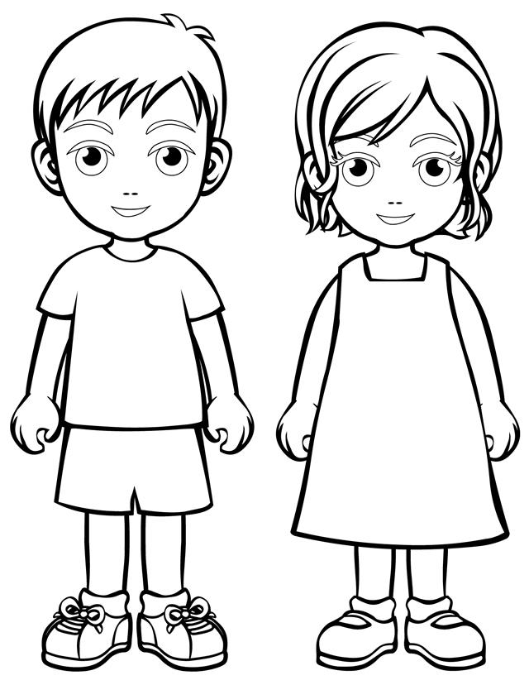
Teacher reads the following instructions:
- Colour the boy’s shorts red.
- Colour the girl’s dress yellow.
- Colour the boy’s shorts blue.
[3]
Reading
Task 2. Read, spell and match pictures to the words.

1. |  | Friends
2. |  | Football
3. |  | Help
[3]

Writing

Task 3. Complete the words.

Teacher can read the words ‘hat, coat, trousers, socks’ or initial letters from the box.

Tr C H

- 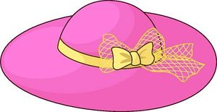 | ___at
 | ____ oat
 | _____ ousers
[3]

Use of English
Task 4. Look at the pictures and make up 2 sentences.

- 2.

3. 4.
[2]
Speaking

Task 5. Look at the pictures and ask your classmate 3 questions. Use some words from the box in your answers.

Yes, please. No problem. Sure. Here you are. Sorry, I need it.
Sorry, it’s not mine. Sorry, I cannot.
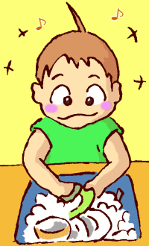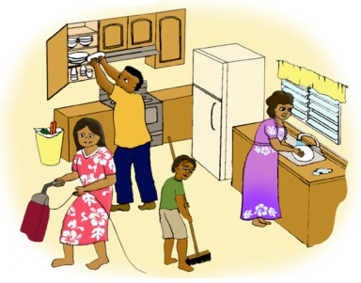
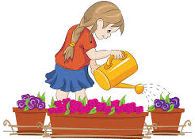
Example:
- P1.: Can you wash the dishes?
- P2.: Sure.
- P1.: Can you cross the street?
- P2.: Yes, I can.
- P1: Can you help me with cleaning?
- P2: No problem.
- P1: Can you give me the book, please?
- P2: Here you are.
[3]

Mark scheme

Task № | Answer | Mark | Additional information
1. | Colours the boy’s shorts red. | 1
 | Colours the girl’s dress yellow. | 1
 | Colours the boy’s shorts blue. | 1
2 | Matches 1st picture to the word ‘Football’ correctly; | 1
 | Matches 2rd picture to the word ‘Help’ | 1
 | Matches 3th picture to the word ‘Friends’ | 1
3. | 1.Hat | 1
 | 2.Coat | 1
 | 3.Trousers | 1
4 | The boy has got a puppy/a dog. / | 2 | Learner should makes up 2 sentences for any pictures. Any other answers are acceptable if learners use singular and/or plural nouns in the sentences to describe the pictures. One mark is awarded for 1 correct sentence.
 | There are many books./ Children have got many books.
 | The boy has got 3 gifts/ presents.
 | The girl has got 4 balloons/ beautiful balloons.
5 | Possible questions and answers:  Can you wash the dishes? / Yes, I can / I can wash dishes / Sure / No, I cannot | 3 | Learners should ask only 3 questions. Any other questions are acceptable if they are grammatically correct. One mark is awarded for 1 correct question.
 | Can you cross the street? / Yes, I can / Sure / I can cross the street / No problem / No, I cannot
 | Can you help me with cleaning? / Yes, I can / Sure / No problem / I can clean the house / I can help you with cleaning / Sorry, I cannot
 | Can you give me the book, please? / Sorry, It’s not mine / Yes, I can / Yes, please / Here you are / Sorry, I need it
Total marks |  | 14

5. Administration rules
During the Assessment cover all visual materials like, diagram, schemes, posters and maps that can serve as prompts for the learners.
At the beginning of the Assessment read out the instructions and inform the learners about the assessment duration. Remind learners that they are not allowed to talk with each other during the Summative Assessment. After the instructions, make sure they have understood given instructions and ask if they have any questions before the start of the assessment.
Ensure that the learners are working individually and not helping each other. During the Summative Assessment learners should not have any access to additional recourses that can help them, for example, dictionaries (excluding the cases when it is allowed in specification)
Recommend learners to cross the wrong answers instead of using an eraser.
During the assessment you can answer learners’ questions, regarding the instructions and the assessment duration. You should not spell, paraphrase or provide any information that could give the learner an advantage.
Always tell the learners that they have 15 and 5 minutes left before the end of the Summative Assessment.
Tell the learners to stop writing and put down their pens/pencils on the desks at the end of the Summative Assessment.

6. Moderation and marking
All teachers use the same version of the mark scheme. During the moderation process it is necessary to check learner sample papers with the marks awarded to ensure there are no deviations from the standardized mark scheme.

TERM 2

SUMMATIVE ASSESSMENT TASKS

Summative Assessment for the Cross curricular unit “My school”

Learning objectives | 2.L3 Understand the main points of short, slow and carefully articulated talk on routine and familiar topics features such as colour and number  2.W7 Spell some familiar high–frequency words accurately during guided writing activities
Assessment criteria | - Recognise the main idea in a short talk on routine and familiar topics such as colour and number  - Write familiar high–frequency words accurately
Level of thinking skills | Knowledge and comprehension  Application
Duration | 15 minutes
Listening

Task 1. Listen and number the pictures.
Teacher reads sentences
1. It is a yellow room. You can jump and run in this room.
2. There are 5 computers in this room. You can work there.
3. There are many books there. You can come and read them.
4. There are food and drinks in the room. You can eat there.

A |  | B
C |  | D

Writing
Task 2. Write the name of the objects.
Teacher reads the words
- Chair
- Table
- Pencil
- Bag
- Book

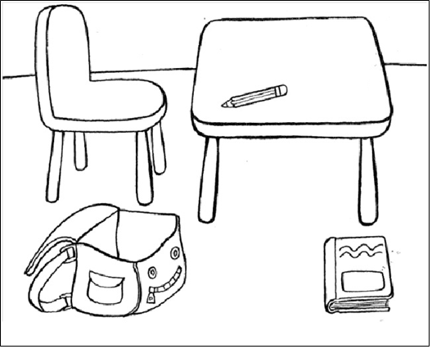

- ___________________
- ___________________
- ___________________
- ___________________
- ___________________

Assessment criteria | Task № | Descriptor | Mark | Additional information
 |  | A learner
Recognise the main idea in a short talk on familiar topics such as colour and number | 1 | writes № 3 for A | 1
 |  | writes №1for B | 1
 |  | writes №4 for C | 1
 |  | writes № 2 for D | 1
Write familiar high-frequency words accurately | 2 | writes ‘chair’ | 1 | Learner can write in any order. 1 mark for each correct answer.
 |  | writes ‘table’ | 1
 |  | writes ‘pencil’ | 1
 |  | writes ‘bag’ | 1
 |  | writes ‘book’ | 1
Total marks |  |  | 9

Rubrics for providing information to parents on the results of Summative Assessment for the unit “My school”

Learner’s name ____________________________________

Assessment  criteria | Level of learning achievements
 | Low | Middle | High
Recognise the main idea in a short talk on routine and familiar topics such as colour and number | Experiences challenges in recognizing the main information in the sentences | Good at identifying main information in the sentences. Some minor problems at recognizing school’s rooms: library/ gym/ canteen/ /computer | Confident at identifying main information in the sentences. Completes the task correctly
Write familiar high-frequency words accurately | Experiences challenges in writing school objects | Makes mistakes in writing school objects: chair/ table/ bag/ book/ pencil | Correctly writes school objects

Summative Assessment for the Cross curricular unit “The world around us”

Learning objectives | 2.S3 Use a limited range of basic words, phrases and short sentences to describe objects, activities and classroom routines  2.UE13 Use can to talk about ability and to make requests and offers; use can / can’t to talk about permission
Assessment criteria | - Apply basic words, phrases and short sentences in a talk about objects, activities and classroom routines  - Talk about ability, make requests and offers, and ask for permission using can and can’t
Level of thinking skills | Application
Duration 20 minutes

Speaking

Task 1. Describe the picture. Use the words from the box.

Flag Kazakhstan Russia Great Britain Japan

Use of English
Task 2. Look at the road signs. Choose can or can’t to complete the sentences.

1. | 2. | 3. | 4.
- Stop! You …………….. go. (can / can’t)
- Danger! You ………….. enter. (can / can’t)
- Go! You ………..… go. (can / can’t)
- Bicycle! You ………… ride a bike. (can / can’t)

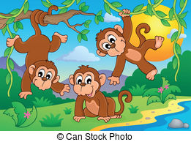
Task 3. Read the statements about monkeys. Write “True” (T) or “False” (F) next to the sentence.
T F
- Monkeys can walk. __ __
- They can play tennis. __ __
- They can fly. __ __

Assessment criteria | Task№ | Descriptor | Mark | Additional information
 |  | A learner
Apply basic words, phrases and short sentences in a talk about objects, activities and classroom routines | 1 | Possible answers:  This/It is the flag of Kazakhstan. | 1 | Any answers are acceptable if they describe the flag. One mark is awarded for each correct phrase and sentence.
 |  | The flag/It is blue. | 1
 |  | There is the sun/It has the sun. | 1
Talk about ability, make requests and offers, and ask for permission using can and can’t. | 2 | - completes the sentence using can’t | 1
 |  | - completes the sentence using can’t | 1
 |  | - completes the sentence using can | 1
 |  | - completes the sentence using can | 1
 | 3 | - writes ‘T/ True’ | 1
 |  | - writes ‘F/ False’ | 1
 |  | - writes ‘F/ False’ | 1
Total marks |  |  | 10

Rubrics for providing information to parents on the results of Summative Assessment for the unit “The world around us”

Learner’s name ___________________________________________

Assessment  criteria | Level of learning achievements
 | Low | Middle | High
Apply basic words, phrases and short sentences in a talk about objects, activities and classroom routines | Experiences challenges in using topic words to describe the pictures of flags | Makes mistakes in using topic words Flag/ Kazakhstan/ Russia/ Great Britain/ Japan to describe the picture | Confidently uses topic words to describe the picture
Talk about ability, make requests and offers, and ask for permission using can and can’t | Experiences challenges in using can and can’t to make up sentences; and in identifying the main information of the statements using supporting picture | Makes mistakes in using can and can’t to make up sentences on road sings. Makes mistakes in identifying statements for True /False using the picture | Confidently uses can and can’t to make up sentences. Correctly identifies sentences for True and False statements

Specification of Summative Assessment for term 2

- Aim of summative assessment
Summative assessment is aimed to assess learners’ success in terms of the learning objectives achievement and reveal their level of knowledge and skills acquired during the term within the framework of updating the secondary education content.
Specification describes the content and procedure for the delivery of the Summative Assessment for the term in “English” in Grade 2.

2. The document defining the content of the Summative Assessment for the term
Subject Programme in “English” (within the framework of updating the secondary education content) for primary education (Grades 1 – 4).

3. Review of Summative Assessment for term 2.

3.1 Duration - 40 minutes.
Total marks –14.
Speaking task is conducted separately.

3.2. The structure of the Summative Assessment
Different types of multiple choice and open-ended tasks are used in the Summative Assessment for term.
This Assessment consists of 5 tasks. Matching choice tasks require learners to connect heard information with right picture. Open-ended tasks require learners follow instructions, answer questions in words, expressions and sentences. Gap filling tasks require learners to put word(s) in the spaces provided.

Cross curricular unit | Strand | Learning objective | Task № | Type of question/  Task description | Total marks
My school.  The world around us. | Listening | 2.L1 Understand a range of short basic supported classroom instructions | 1 | Matching task.  Learners listen to the teacher and tick the heard instructions. | 3
 | Reading | 2.R3 Read and follow with considerable support simple words, phrases and sentences on familiar topics. | 2 | Matching task.  Learners read the name of road signs and match them to their pictures. | 3
 | Writing | 2.W7 Spell some familiar high-frequency words accurately during guided writing activities | 3 | Open-ended task.  Learners construct words from the given letters. | 3
 |  | 2. UE2 Use cardinal numbers 1-50 to count | 4 | Gap filling task  Leaners have to count and write the number of objects according to the pictures. | 2
 | Speaking | 2.S3 Use a limited range of basic words, phrases and short sentences to describe objects, activities and classroom routines | 5 | Open-ended task.  Learners answer questions using supporting pictures. | 3

Sample questions for the 2nd term and mark scheme

Listening
Task 1. Listen to the teacher twice. Tick () what you hear. Three pictures are odd.
Teacher reads the instructions
- Look at the board!
- Open your books!
- Listen!

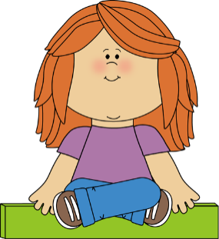
[3]
Reading

Task 2. Read the road signs and match them to the pictures.

Cross the road Bus stop Don’t go

1. 2. 3.
[3]
Writing

Task 3. Write words from the following letters.

- Abrliry | __________
- Mgy | __________
- Coolsh | __________

[3]

Use of English

Task 4. Count and complete the sentences.
1. | There are _______________ computers.
2. | There are ________________ colours.

[2]
Speaking

Task 5. Look at the picture. Answer the following questions:

- How many children are there in the photo?
- Who are they?
- What do they do?
[3]

Mark scheme
Task № | Answer | Mark | Additional information
1 | Look at the board | 1
 | Open your books | 1
 | Listen | 1
2. | Don’t go | 1
 | 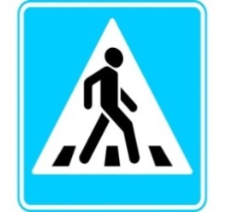Cross the road | 1
 | Bus stop | 1
3 | - library | 1
 | - gym | 1
 | - school | 1
4 | - 2/ two | 1
 | - 4/ four | 1
5 | Three/ There are three children | 1 | Short answers are acceptable if they answer the questions correctly.
 | Pupils/students/friends/brother and sisters/ They are pupils/students/friends/brother and sisters | 1
 | They are drawing/painting./They draw/paint. | 1
Total marks |  | 14

5. Administration rules
During the Assessment cover all visual materials like, diagram, schemes, posters and maps that can serve as prompts for the learners.
At the beginning of the Assessment read out the instructions and inform the learners about the assessment duration. Remind learners that they are not allowed to talk with each other during the Summative Assessment. After the instructions, make sure they have understood given instructions and ask if they have any questions before the start of the assessment.
Ensure that the learners are working individually and not helping each other. During the Summative Assessment learners should not have any access to additional recourses that can help them, for example, dictionaries (excluding the cases when it is allowed in specification)
Recommend learners to cross the wrong answers instead of using an eraser.
During the assessment you can answer learners’ questions, regarding the instructions and the assessment duration. You should not spell, paraphrase or provide any information that could give the learner an advantage.
Always tell the learners that they have 15 and 5 minutes left before the end of the Summative Assessment.
Tell the learners to stop writing and put down their pens/pencils on the desks at the end of the Summative Assessment.

6. Moderation and marking
All teachers use the same version of the mark scheme. During the moderation process it is necessary to check learner sample papers with the marks awarded to ensure there are no deviations from the standardized mark scheme.

TERM 3

SUMMATIVE ASSESSMENT TASKS

Summative Assessment for the Cross curricular unit “Health and body”

Learning objectives | 2.S3 Use a limited range of basic words, phrases and short sentences to describe objects, activities and classroom routines  2.R3 Read and follow with considerable support simple words, phrases and sentences on familiar topics
Assessment criteria | - Talk about objects, activities and classroom routines using topic words, phrases and short sentences  - Use and follow with considerable support simple words, phrases, sentences in reading familiar topics
Level of thinking skills | Application
Duration | 20 minutes
Speaking

Task 1. Look at the pictures. Describe them. Tell what you can see on the pictures.

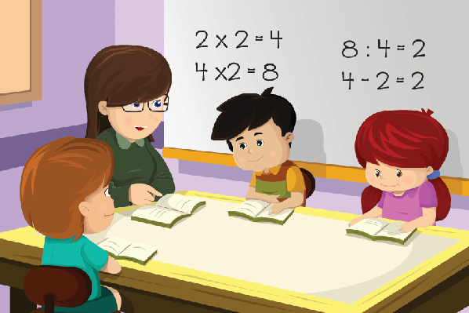

Reading
Teacher asks learners to prepare three coloured pencils: red, blue and yellow.

Task 2. Read and circle.

Circle the “head” in red.
Circle the” hand” in blue.
Circle the “leg” in yellow.

Task 3. Read the sentences and match them to the pictures.
A girl is brushing her teeth.
A girl is writing with a pencil.
A boy is reading a book.

Assessment criteria | Task№ | Descriptor | Mark | Additional information
 |  | A learner
Talk about objects, activities and classroom routines using topic words, phrases and short sentences. | 1 | Possible answers
 |  | I can see books/desks./ The learners are reading books. | 1 | Any other answers are acceptable until they describe the picture (objects, activities, classroom routines).
 |  | I can see numbers. /They do sums./ The learners are solving problems. | 1
 |  | I can see the teacher. / I can see children./ The teacher is helping learners. | 1
 |  | The learners are in the class./ It is a classroom. | 1
Use and follow with considerable support simple words, phrases, sentences in reading familiar topics. | 2 | circles “head” in red; | 1
 |  | circles “hand” in blue; | 1
 |  | circles “leg” in yellow; | 1
 | 3 | matches “A girl is brushing her teeth” to the 3rd picture; | 1
 |  | matches “A girl is writing with a pencil” to the 1st picture; | 1
 |  | matches “A boy is reading a book.” to the 2nd picture. | 1
Total marks |  |  | 10

Rubrics for providing information to parents on the results of Summative Assessment for the Cross curricular unit “Health and body”

Learner’s name ___________________________________

Assessment criteria | Level of learning achievements
 | Low | Middle | High
Talk about objects, activities and classroom routines using topic words, phrases and short sentences | Experiences difficulties in using topical vocabulary. Describes the pictures inappropriately | Makes mistakes in naming objects and activities. Experiences minor challenges in making up sentences, grammar and pronunciation | Fully completes the task. Confidently uses topic vocabulary, speaks in full sentences with grammar accuracy. Pronunciation is clear
Use and follow with considerable support simple words, phrases, sentences as a support in reading familiar topics | Experiences challenges in reading the sentences and in following commands. Matches most of the sentences to their pictures incorrectly | Makes mistakes in reading and following the commands: circle the “head” in red/ circle the” hand” in blue/ circle the “leg” in yellow and in matching “A girl is brushing her teeth” to the 3rd picture/ “A girl is writing with a pencil” to the 1st picture/ “A boy is reading a book.” to the 2nd picture | Adresses the task fully. Reads the sentences and circles pictures correctly. Matches sentences to their pictures accordingly

Summative Assessment for the Cross curricular unit “Traditions and customs”

Learning objectives | 2.L9 Recognize the spoken form of familiar words and expressions  2.UE8 Use simple imperative forms [positive and negative] for basic commands and instructions
Assessment criteria | - Identify familiar words and expressions in a talk  - Apply the positive and negative forms for basic commands and instructions
Level of thinking skills | Knowledge and comprehension  Application
Duration | 20 minutes

Listening

Task 1. Listen to the sentence. Choose the correct option and put in the right box.

№ | A | B | C
1.We can see the flag on Independence day. |  | 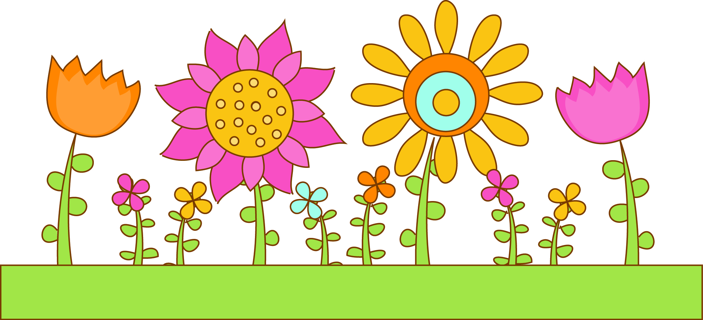
2.There are many presents on New Year’s day.

3.There are many flowers on Nauryz.

Task 2. Fill in the gap with the word to make instructions.
Make | Cook | Visit | Wear | late

Nauryz
 | - ____________ |  | friends.
 | - ____________ |  | baursaks, beshbarmak and tea. |  | 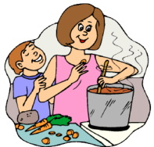
 | - ____________ |  | beautiful national clothes. |  | 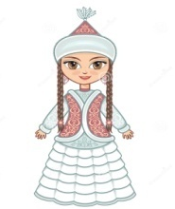
 | - ____________ |  | gifts.
 | - Don’t be |  | ________________!
Assessment criteria |  | Task |  | Descriptor |  | Mark
 |  |  |  | A learner
Identify familiar word and expression in a talk. |  | 1 |  | chooses 1.A |  | 1
 |  |  |  | chooses 2.B |  | 1
 |  |  |  | chooses 3.C |  | 1
Apply the positive and negative forms for the basic commands and instructions. |  | 2 |  | - writes ‘Visit’ |  | 1
 |  |  |  | - writes ‘Cook’ |  | 1
 |  |  |  | - writes ‘Wear’ |  | 1
 |  |  |  | - writes ‘Make’ |  | 1
 |  |  |  | - writes ‘late’ |  | 1
Total marks |  |  |  |  |  | 8

Rubrics for providing information to parents on the results of Summative Assessment for the Cross curricular unit “Traditions and customs”

Learner’s name ___________________________________

Assessment criteria | Level of learning achievements
 | Low | Middle | High
Identify familiar words and expressions in a talk | Experiences challenges in recognizing topical words and in choosing correct options according to the talk | Makes mistakes in identifying topical vocabulary for Independence Day/ New Year’s Day / Nauryz and in marking appropriate pictures according to the talk | Fully completes the task. Confident in identifying topical vocabulary and in marking appropriate pictures according to the talk
Apply the positive and negative forms for the basic commands and instructions | Experiences challenges in making commands and instructions | Makes mistakes in making commands and instructions on the topic: Visit friends. / Cook baursaks, beshbarmak and tea./ Wear beautiful national clothes./ Make presents/ Don’t be late! | Adresses the task fully. Makes instructions properly

Specification of Summative Assessment for Term 3

- Aim of the Summative Assessment for the term

Summative Assessment is aimed to assess learners’ success in terms of the learning objectives achievement and reveal their level of knowledge and skills acquired during the term within the framework of updating the secondary education content.
Specification describes the content and procedure for the delivery of the Summative Assessment for the term in “English” in Grade 2.

2. The document defining the content of the Summative Assessment for the term

Subject Programme in “English” (within the framework of updating the secondary education content) for primary education (Grades 1 – 4).

3. Review of Summative Assessment for term 3.

3.1 Duration - 40 minutes.
Total marks –14.
Speaking task is conducted separately.

3.2. The structure of the Summative Assessment

Different types of multiple choice and open-ended tasks are used in the Summative Assessment for term.
This Assessment consists of 5 tasks. Multiple choice tasks require learners choose one correct answer. Open-ended tasks require learners follow instructions, answer questions in words, expressions and sentences. Gap filling tasks require learners to put word(s) in the spaces provided.

Cross curricular unit | Strand | Learning objective | Task № | Type of question/  Task description | Total marks
Health and body. Traditions and Customs | Listening | 2.L5 Identify missing phonemes in incomplete words | 1 | Gap filling task.  Learners choose the appropriate letters to complete the words | 3
 | Reading | 2.R1 Read and spell out words for others | 2 | Multiple choice task.  Learners look at the pictures, read and find the correct word and spell it | 3
 | Writing | 2.W7 Spell some familiar high-frequency words accurately during guided writing activities | 3 | Open-ended task.  Learners write the words and spell them | 3
 |  | 2.UE13 Use can to talk about ability and to make requests and offers; use can / can’t to talk about permission | 4 | Gap filling task.  Learners look at the pictures and insert the correct verb or expression into the gap | 2
 | Speaking | 2.S8 Give simple instructions for others to follow | 5 | Open ended task.  Learners look at the pictures and give simple instructions to each other | 3

Sample questions and mark scheme

Tasks for the Summative Assessment for the Term 3

Listening
Task 1. Listen to the teacher and fill in the gaps with appropriate letters.
Teacher reads the words:
Fish
Brush
Cheese
br sh ch
fi_ _ | _ _ ush  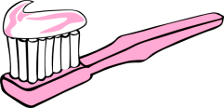 | _ _eese  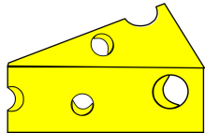
[3]

Reading

Task 2. Read the words. Find the parts of the head, circle and spell them.

 | 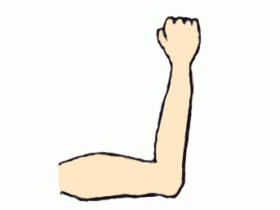 |  | 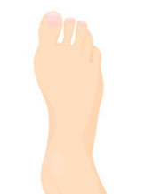
ear | arm | mouth | foot
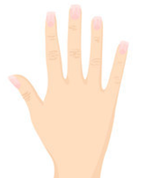
hand | eye

[3]

Writing
Task 3. Write the missing words in the sentences.
1. | You eat a ________________ |  | at the birthday Party!
2. | They can see many ___________ |  | on Independence Day!
3. | We wear ______________ clothes |  | on Nauryz Day.
[3]

Use of English

Task 4. Look at the pictures. Write simple sentences about what you can/ can’t do.

Example: I can speak English. 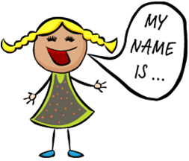
- You ____________ take my book.
- _________ I help you?

[2]

Speaking

Task 5. Look at the pictures and give instructions to your classmates.

1. 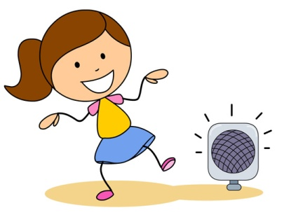 2. 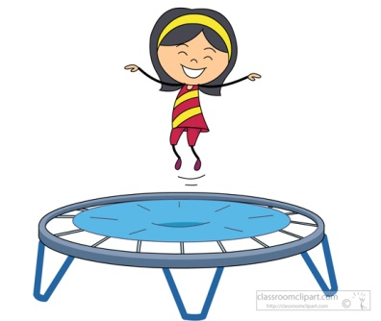 3.

[3]

Mark scheme

Task № | Answer | Mark | Additional information
1 | Fish | 1
 | Brush | 1
 | Cheese | 1
2 | Ear | 1 | These words may come in any order.
 | Mouth | 1
 | Eye | 1
3 | - cake | 1
 | - flags | 1
 | - national | 1
4 | - You can take my book. | 1
 | - Can I help you? | 1
5 | Dance! | 1
 | Jump! | 1
 | Write! | 1
Total marks |  | 14

5. Administration rules
During the Assessment cover all visual materials like, diagram, schemes, posters and maps that can serve as prompts for the learners.
At the beginning of the Assessment read out the instructions and inform the learners about the assessment duration. Remind learners that they are not allowed to talk with each other during the Summative Assessment. After the instructions, make sure they have understood given instructions and ask if they have any questions before the start of the assessment.
Ensure that the learners are working individually and not helping each other. During the Summative Assessment learners should not have any access to additional recourses that can help them, for example, dictionaries (excluding the cases when it is allowed in specification)
Recommend learners to cross the wrong answers instead of using an eraser.
During the assessment you can answer learners’ questions, regarding the instructions and the assessment duration. You should not spell, paraphrase or provide any information that could give the learner an advantage.
Always tell the learners that they have 15 and 5 minutes left before the end of the Summative Assessment.
Tell the learners to stop writing and put down their pens/pencils on the desks at the end of the Summative Assessment.

6. Moderation and marking
All teachers use the same version of the mark scheme. During the moderation process it is necessary to check learner sample papers with the marks awarded to ensure there are no deviations from the standardized mark scheme.

TERM 4

SUMMATIVE ASSESSMENT TASKS

Summative Assessment for the Cross curricular unit “The natural environment”

Learning objectives | 2.L4 Recognise with support short basic questions relating to features such as colour and number  2.UE13 Use can to talk about ability and to make requests and offers; use can / can’t to talk about permission
Assessment criteria | - Identify short questions on curricular topics with support such as colour and number  - Talk about ability, make requests and offers, and ask for permission using can and can’t
Level of thinking skills | Knowledge and comprehension  Application
Duration | 20 minutes
Listening

Task 1. Listen to the teacher and answer 3 questions.
Teacher should ask 3 questions.
- Are the trees green in autumn?
- Are the trees white in winter?
- Are there flowers in summer?
- Are there 3 seasons in a year?
- Are there 5 months in autumn?
- Do we celebrate the New Year in winter?
- Is your big holiday in spring?

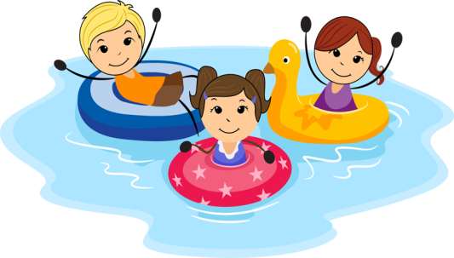

Use of English

Task 2.

- Look at the pictures and tell what you can and cannot do at the Zoo.

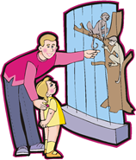
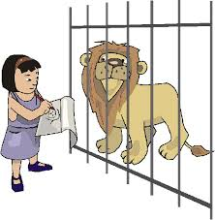
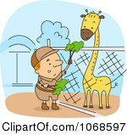

B. Look at the pictures and tell what you can do as animals can.

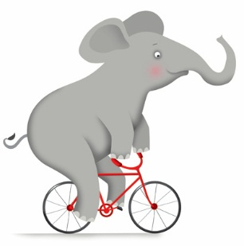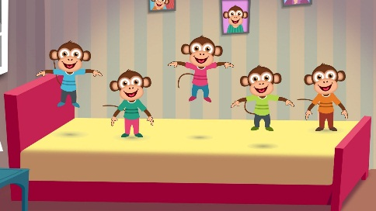

C. Look at the pictures and make a request or offer.

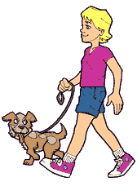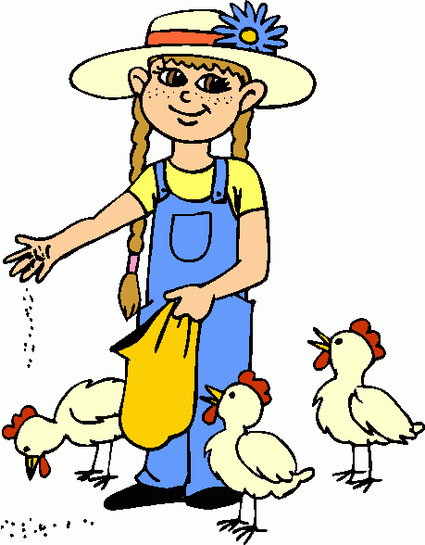

Assessment criteria | Task | Descriptor | Mark | Additional information
 |  | A learner
Identify short questions on curricular topics with support such as colour and number. | 1 | - No./No, there are not. | 3 | Learners should answer 3 questions correctly. One mark is awarded for each answer.
 |  | - Yes./ Yes, they are.
 |  | - Yes./ Yes, there are.
 |  | - No./No, there are not.
 |  | - No./No, there are not.
 |  | - Yes./ Yes, I do.
 |  | - No./No, it is not.
Talk about ability, make requests and offers, and  ask for permission using can and can’t. | 2 | Possible answers  - You cannot feed animals./  You cannot stand very close to animals./  You can come to the Zoo with your parents. | 1 | Any other answers are acceptable if they describe pictures using can and can’t appropriately.
 |  | - I can ride a bike like an elephant./  I can jump on the sofa like monkeys. | 1
 |  | - Can I take a dog for a walk?/  Can I feed the chickens? | 1
Total marks |  |  | 6

Rubrics for providing information to parents on the results of Summative Assessment for the Cross curricular unit “The natural environment”

Learner’s name ___________________________________

Assessment criteria | Level of learning achievements
 | Low | Middle | High
Identify short questions on curricular topics with support such as colour and number | Experiences challenges in answering the questions | Makes mistakes in answering basic questions YES. (Yes, they are. Yes, there are. Yes, I do.)/ NO. (No, there are not. No it is not.) | Answers to the questions correctly
Talk about ability, make requests and offers, and ask for permission using can and can’t | Experiences challenges in using can and can’t in a talk | Makes mistakes in using can and can’t in a talk | Adresses the task fully. Confidently uses can and can’t in a talk

Summative Assessment for the Cross curricular unit “Travel”

Learning objectives | 2.R3 Read and follow with considerable support simple, words, phrases and sentences on familiar topics  2.S4 Respond to basic supported questions giving personal and factual information
Assessment criteria | - Use and follow with considerable support words, phrases, sentences in reading familiar topics  - Answer basic questions with support  - Provide personal information and facts
Level of thinking skills | Knowledge and comprehension  Application
Duration | 20 minutes
Reading

Task 1. Read and follow the instructions.

- There is a bus. Put a tick.
2. Cross the plane.
3. Circle the red car.

Task 2. Listen to the teacher and answer the questions.

1. What is your name?
2. Can you ride a bike?
3. Do you go to school by bus?
4. What types of vehicles do you know?
5. Do you fly by plane?

Assessment criteria | Task | Descriptor | Mark | Additional information
 |  | A learner
Use and follow with considerable support words, phrases, sentences in reading familiar topics. | 1 | puts a tick near the bus; | 1
 |  | crosses the plane; | 1
 |  | circles the red car; | 1
Answer basic questions with support.  Provide personal information. | 2 | Possible answers  My name is Amir. | 1 | Any other answers are acceptable if they respond to the questions appropriately.
 |  | I can/can’t ride a bike. | 1
 |  | Yes./Yes, I do. No./No, I don’t. | 1
 |  | I know a bus, a car, a train, a plane, etc. | 1
 |  | Yes./Yes, I do. | 1
Total marks |  |  | 8

Rubrics for providing information to parents on the results of Summative Assessment for the Cross curricular unit “Travel”

Learner’s name ___________________________________

Assessment criteria | Level of learning achievements
 | Low | Middle | High
Use and follow with considerable support words, phrases, sentences in reading familiar topics | Experiences challenges in recognizing instructions. Most of the answers are incorrect | Makes mistakes in identifying instruction and following them accordingly | Fully completes the task. Confident in identifying instructions and follows instructions correctly
Answer basic questions with support.  Provide personal information | Experiences challenges in answering the questions | Makes mistakes in answering personal questions | Adresses the task fully. Answers the questions appropriately

Specification of Summative Assessment for term 4

- Aim of the Summative Assessment for the Term

Summative Assessment is aimed to assess learners’ success in terms of the learning objectives achievement and reveal their level of knowledge and skills acquired during the term within the framework of updating the secondary education content.
Specification describes the content and procedure for the delivery of the Summative Assessment for the term in “English” in Grade 2.

2. The document defining the content of the Summative Assessment for the term

Subject Programme in “English” (within the framework of updating the secondary education content) for primary education (Grades 1 – 4).

3. Review of Summative Assessment for term 4.

3.1 Duration - 40 minutes.
Total marks –14.
Speaking task is conducted separately.

3.2. The structure of the Summative Assessment

Different types of multiple choice and open-ended tasks are used in the Summative Assessment for term.
This Assessment consists of 5 tasks. Multiple choice tasks require learners choose one correct answer. Open-ended tasks require learners follow instructions, answer questions in words, expressions and sentences.

Cross curricular unit | Strand | Learning objective | Task № | Type of question/  Task description | Total marks
The natural environment.  Travel | Listening | 2.L3 Understand the main points of short, slow and carefully articulated talk on routine and familiar topics such as colour and number | 1 | Multiple choice task.  Learners colour and draw pictures according to the instructions | 3
 | Reading | 2.R3 Read and follow with considerable support simple words, phrases and sentences on familiar topics | 2 | Multiple choice task.  Learners read and underline the sentences describing winter | 3
 | Writing | 2.W5 Write letters and familiar high frequency words when read aloud or spelt out for learners | 3 | Open-ended task.  Learners write the missing words | 3
 | Speaking | 2.UE10 Use common present continuous forms [positive, negative, question] | 4 | Open-ended task.  Learners answer the questions using present continuous forms | 2
 |  | 2.S3 Use a limited range of basic words, phrases and short sentences to describe objects, activities and classroom routines | 5 | Open-ended task.  Learners describe objects, activities and classroom routines using topic words, phrases and short sentences | 3

Tasks for the Summative Assessment for the Term 4

Listening
Task 1. Listen to the teacher and follow the instructions.
Teacher asks learners to prepare two coloured pencils: red and blue.
- Circle a starfish in red.
- Colour a whale into blue.
- How many jelly fish are there? Count and circle: 2 3 1
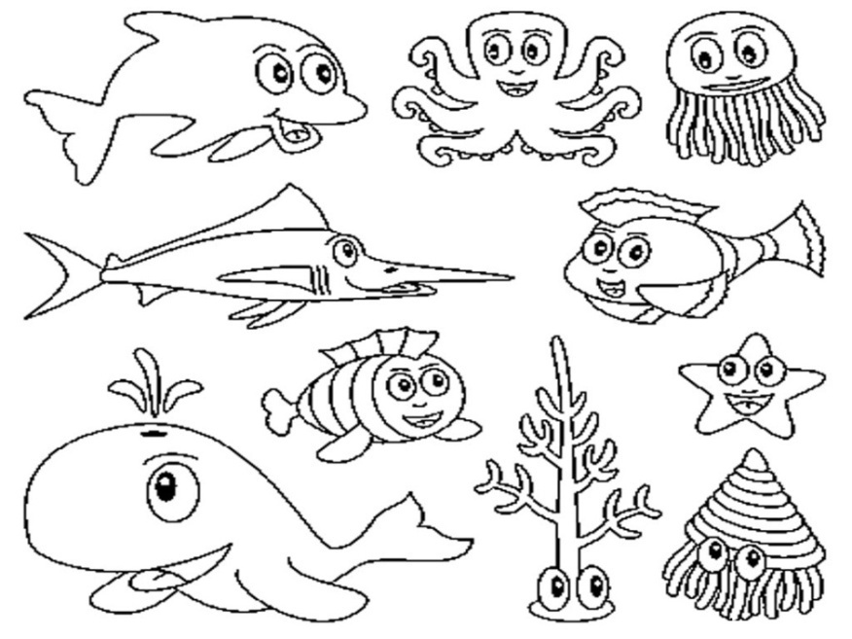

[3]

Reading

Task 2. Look at the picture. Read the sentences. Underline the sentences that describe the picture.

- Children are going to the lake to swim.
- It is very cold.
- Children are playing snowballs and skating.
- The weather is very hot.
- The trees are white with snow.

[3]

Writing
Task 3. Write the missing word in the sentence.
Teacher reads the sentences.
- We go to school by a school bus.
- He flies to London by plane.
- They can go to Astana by train.

1. | We go to school by a ___________________. | 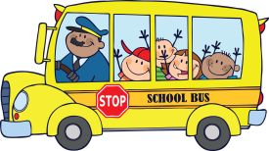
2. | He flies to London by ___________________.
3. | They can go to Astana by _______________.
[3]
Use of English

Task 4. Look at the pictures and answer the questions.

Teacher chooses one card for each learner.

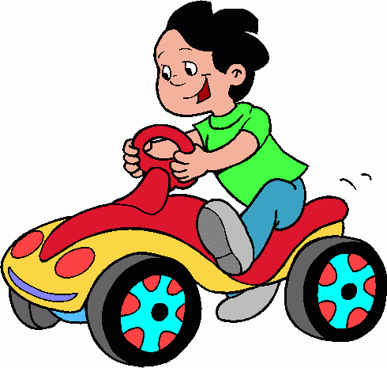  - What is he doing?  - What colour T-shirt is he wearing? | 1. What season is it?  2. What colour is the boat? | 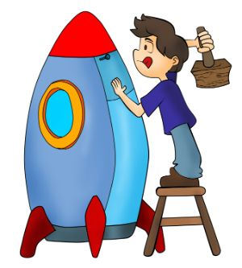  1. Where is he standing?  2. What colour jeans is he wearing?

[2]

Speaking

Task 5. Look at the pictures. Name the vehicle and describe it.
1. 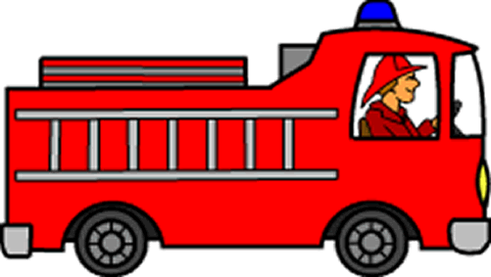 2. 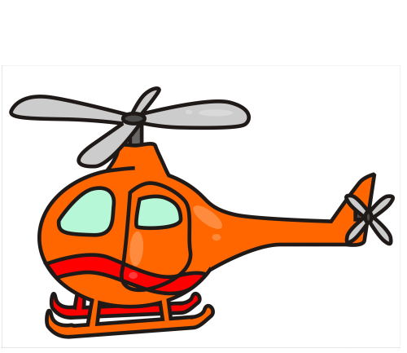 3.

[3]
Mark scheme
Task № | Answer | Mark | Additional information
1 | Circles a starfish in red. | 1
 | Colours a whale into blue. | 1
 | Circles number 2. | 1
2 | It is very cold. | 1 | A learner chooses three sentences about winter and underlines them.
 | Children are playing snowballs and skating. | 1
 | The trees are white with snow. | 1
3 | - school bus | 1
 | - plane | 1
 | - train | 1
4 | He is driving a motobike. | 1 | He is not riding a bike.
 | He is wearing a green T-shirt. | 1
5 | Possible answers.  This is a fire machine/ a helicopter/ a rocket.  It is big/ red/ blue.  It can fly.  It moves. | 3 | A learner chooses any kind of transportation. Names it. Tells about its size and colour. Names the action vehicle can do.
Total marks |  | 14

5. Administration rules
During the Assessment cover all visual materials like, diagram, schemes, posters and maps that can serve as prompts for the learners.
At the beginning of the Assessment read out the instructions and inform the learners about the assessment duration. Remind learners that they are not allowed to talk with each other during the Summative Assessment. After the instructions, make sure they have understood given instructions and ask if they have any questions before the start of the assessment.
Ensure that the learners are working individually and not helping each other. During the Summative Assessment learners should not have any access to additional recourses that can help them, for example, dictionaries (excluding the cases when it is allowed in specification)
Recommend learners to cross the wrong answers instead of using an eraser.
During the assessment you can answer learners’ questions, regarding the instructions and the assessment duration. You should not spell, paraphrase or provide any information that could give the learner an advantage.
Always tell the learners that they have 15 and 5 minutes left before the end of the Summative Assessment.
Tell the learners to stop writing and put down their pens/pencils on the desks at the end of the Summative Assessment.

6. Moderation and marking
All teachers use the same version of the mark scheme. During the moderation process it is necessary to check learner sample papers with the marks awarded to ensure there are no deviations from the standardized mark scheme.

